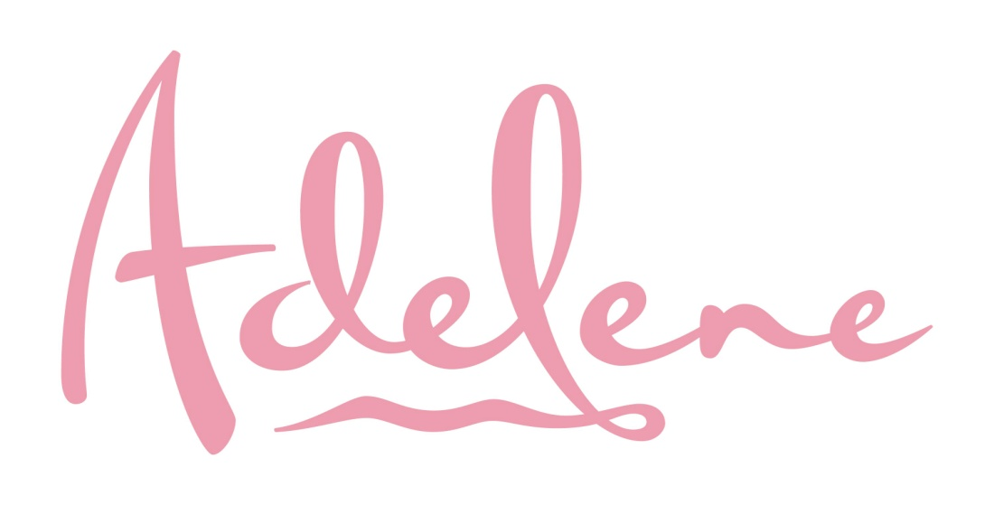
Restaurant Week Specials
June 9-16, 2017

2 For $20
Breakfast

BREAKFAST SANDWICH Cheesesteak, Egg and Cheese on a Bagel

BREAKFAST ROLL-UP Hash Browns with Scrambled Eggs, Cheddar Cheese, and Chipotle Mayo, Served in a Flour Tortilla

2 For $20
Lunch

PORK BBQ SANDWICH with Melted Smoked Gouda Cheese, Chips and Homemade Cole Slaw

1510 Boardwalk Ocean City, NJ * (609) 399-8812 800-334-4546 * www.portocallhotel.com

